**Name of Student: Munja Dnyanoba Solanke**

**University ID: U-0762-5327**

**CPT Term: Spring-2021 – Independent Study**

* **Describe project experiences and what you learned from each.**
* **First Project Experience:** This project named “AcSELerator database Search Engine” is continuation work of the previous semester. I have upgraded the user interface of the application, increased the data deployment using database API and Configuration API. Also, I have provided feedback option in my full stack web application where I can ask customers/clients about the feedback regarding the application or any further features they would like to add into that. Additional new features included like we can check latest firmware version of any product from inventory and go to the link to get latest firmware file to upgrade, and customers can find more details about the Configuration Summary regarding Product details. I have attached the image of homepage of web application at the end of this point.
* Brief description about the project: It was to develop and maintain knowledge in SEL processes and technologies. In this development I did research and analysis on how I can answer all the questions of customers based on SEL’s Inventory Products. So, to get to answers, I analyzed the SEL database and developed “**AcSELerator Database Search Engine**” which will showcase all the query answers based on search text put by customer. This is kind of R&D product which is developed using my prior knowledge learned in subjects like “**Advanced Database Management System**” and “**Distributed Information System**”. So, I learned technologies such as **RESTful API’s, JavaScript, Bootstrap, JQuery, HTML, CSS, C# and Database management** concepts.
* I also learned more about more details about the Software defined networking concepts, **Object oriented programming design patterns** like Factory Method, Singleton. I also learned more about the **.NET Core framework**, **agile development** principle and process, how project management is done, modern web development technologies like **Node.js, React, JavaScript** and database management.

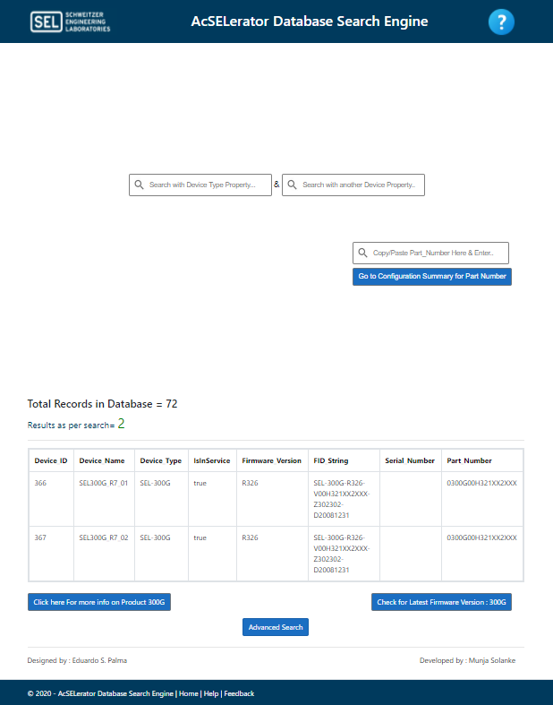

* **Second Project Experience:** I have developed the skills in the visio plugins for configuration creation for the network diagrams. In this I learned how the network diagrams created, how it works, how to resolve the problems if any. There are two different diagrams that need to be created represent all the configuration files.
* Architectural Flow Diagram
  + Represents the physical devices and the how they are connected
  + Specifies the details of their network configurations (IP addresses for example)
  + Hosts and Topology files are created from this diagram
* Data Flow Diagram (DFD)
  + Represents the logical communication on the network
  + Details which devices are talking to which other devices and with which protocols
  + Host Profile, Applications, Protocols files are created from this diagram.
* Many of the configuration files that must be configured to use the Network Builder tools can be configured by using special templates and plugins for Visio.  These make the process of stitching together these files much easier and it also means that you have accurate drawings that completely represent your network configuration.  This means that if you want to make changes to your network you can update the drawings to represent what you want, export the config files, and rerun the NB tools to push that new configuration
* **Third Project Experience:** This project is also continuation of work implementing more robust application features, solving bugs in the previous development. I have developed an user interactive windows UI/UX application named “Automate Firmware Upgrader for SEL SDN switches”. This application has been developed for the R&D communications department. This application is basically using a REST API concepts I learned in my graduate class Distributed Information System. I learned REST API, Python development skills, project management from the subject too I also learned some Project management skills during my internship period. Concept behind design picturized below:

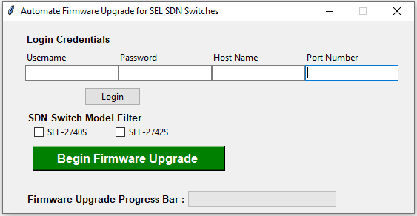

* **Fourth Project Experience**: In this I have learned and modified the Network visualization to display networks and networks consisting of nodes and edges.
* The visualization is easy to use and supports custom shapes, styles, colors, sizes, images, and more. The network visualization works smooth on any modern browser for up to a few thousand nodes and edges.
* To handle a larger number of nodes, Network has clustering support. Network uses HTML canvas for rendering. The network consists of individual modules which handle specific parts of the network. These modules have their own docs, options, methods and events which you can access by clicking on the modules in the list below.

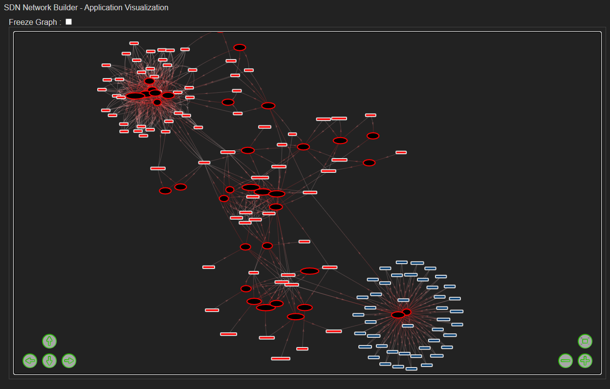

* **Critical analysis of the condition, performance, structure and strategies of the internship organization using multiple data sources.**

During my Internship in SEL company, I learned a lot of things and few things I like to mention are

* One of the important learnings from this is I can practically see what I learned in my graduate classes from Distributed Information System, Advanced database management, project management skills, Enterprise Resource planning and Business process management. Also, I learned some of the Data Visualizations graphs to showcase the work to the clients.
* I grew up and developed professionally, got an exposure of using my academic knowledge professionally.
* I developed critical thinking skills and solution finding approach to problems.
* I developed communication skills both written and oral. I got a chance to communicate with Higher management of the company through different events arranged in SEL.
* I had developed business opportunities to SEL through my work skills.
* I had undergone through different SEL values, principles of operation, and world class Manufacturing Principles.
* Below I will add the lookup page and some reference images:

* **Describe a problem or opportunity related to the internship organization and devise creative solutions to the problem.**
* During my Internship in SEL company, I learned a lot of things and got an opportunity to provide some creative solutions to the problem. So, my R&D work to creative solution will help to SEL customers to understand the Inventory product information from SEL database more clearly and in details.
* Schweitzer Engineering Laboratories, Inc. SEL designs, manufactures, and supports products and services ranging from generator and transmission protection to distribution automation and control systems. This company has invented the world’s first digital protective relay. So SEL sells many of their products to customers. Its always best of company’s interest to provide answers to each question to customers to increase their product sell.
* Similarly, I found an opportunity to provide the answers to all the questions related to Inventory data present in SEL’s database server.
* Overall, I worked on the creative solution under time restrictions with lot of learnings out of it.